Name: Avinash singh, Asadullah Muradi

Roll number: AC-1255, AC-1271

Internet Technologies, 5th Semester

Proxy Servers: Introduction, Working, Type of Proxies, setting up and managing a proxy server

**What is a Proxy Server?**

A proxy server acts as a gateway between you and the internet. It’s an intermediary server separating end users from the websites they browse. Proxy servers provide varying levels of functionality, security, and privacy depending on your use case, needs, or company policy.

If you’re using a proxy server, internet traffic flows through the proxy server on its way to the address you requested. The request then comes back through that same proxy server (there are exceptions to this rule), and then the proxy server forwards the data received from the website to you.

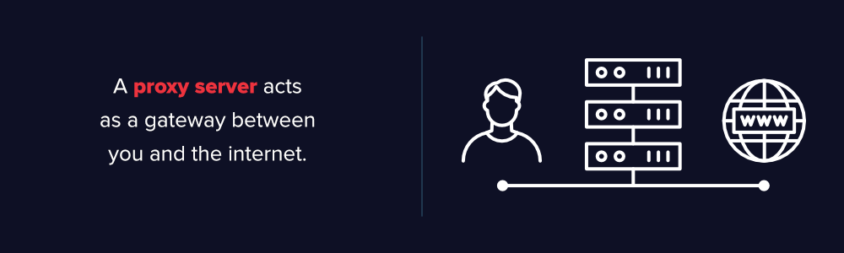

If that’s all it does, why bother with a proxy server? Why not just go straight from to the website and back?

Modern proxy servers do much more than forwarding web requests, all in the name of data security and network performance. Proxy servers act as a firewall and web filter, provide shared network connections, and cache data to speed up common requests. A good proxy server keeps users and the internal network protected from the bad stuff that lives out in the wild internet. Lastly, proxy servers can provide a high level of privacy.

**How Does a Proxy Server Operate?**

Every computer on the internet needs to have a unique Internet Protocol (IP) Address. Think of this IP address as your computer’s street address. Just as the post office knows to deliver your mail to your street address, the internet knows how to send the correct data to the correct computer by the IP address.

A proxy server is basically a computer on the internet with its own IP address that your computer knows. When you send a web request, your request goes to the proxy server first. The proxy server then makes your web request on your behalf, collects the response from the web server, and forwards you the web page data so you can see the page in your browser.

When the proxy server forwards your web requests, it can make changes to the data you send and still get you the information that you expect to see. A proxy server can change your IP address, so the web server doesn’t know exactly where you are in the world. It can encrypt your data, so your data is unreadable in transit. And lastly, a proxy server can block access to certain web pages, based on IP address.

**Why Should You Use a Proxy Server?**

There are several reasons organizations and individuals use a proxy server.

* **To control internet usage of employees and children:**Organizations and parents set up proxy servers to control and monitor how their employees or kids use the internet. Most organizations don’t want you looking at specific websites on company time, and they can configure the proxy server to deny access to specific sites, instead of redirecting you with a nice note asking you to refrain from looking at said sites on the company network. They can also monitor and log all web requests, so even though they might not block the site, they know how much time you spend cyberloafing.
* **Bandwidth savings and improved speeds:**Organizations can also get better overall network performance with a good proxy server. Proxy servers can cache (save a copy of the website locally) popular websites – so when you ask for www.varonis.com, the proxy server will check to see if it has the most recent copy of the site, and then send you the saved copy. What this means is that when hundreds of people hit www.varonis.com at the same time from the same proxy server, the proxy server only sends one request to varonis.com. This saves bandwidth for the company and improves the network performance.
* **Privacy benefits:**Individuals and organizations alike use proxy servers to browse the internet more privately. Some proxy servers will change the IP address and other identifying information the web request contains. This means the destination server doesn’t know who actually made the original request, which helps keeps your personal information and browsing habits more private.
* **Improved security:**Proxy servers provide security benefits on top of the privacy benefits. You can configure your proxy server to encrypt your web requests to keep prying eyes from reading your transactions. You can also prevent known malware sites from any access through the proxy server. Additionally, organizations can couple their proxy server with a Virtual Private Network (VPN), so remote users always access the internet through the company proxy. A VPN is a direct connection to the company network that companies provide to external or remote users. By using a VPN, the company can control and verify that their users have access to the resources (email, internal data) they need, while also providing a secure connection for the user to protect the company data.
* **Get access to blocked resources:**Proxy servers allow users to circumvent content restrictions imposed by companies or governments. Is the local sportsball team’s game blacked out online? Log into a proxy server on the other side of the country and watch from there. The proxy server makes it look like you are in California, but you actually live in North Carolina. Several governments around the world closely monitor and restrict access to the internet, and proxy servers offer their citizens access to an uncensored internet.

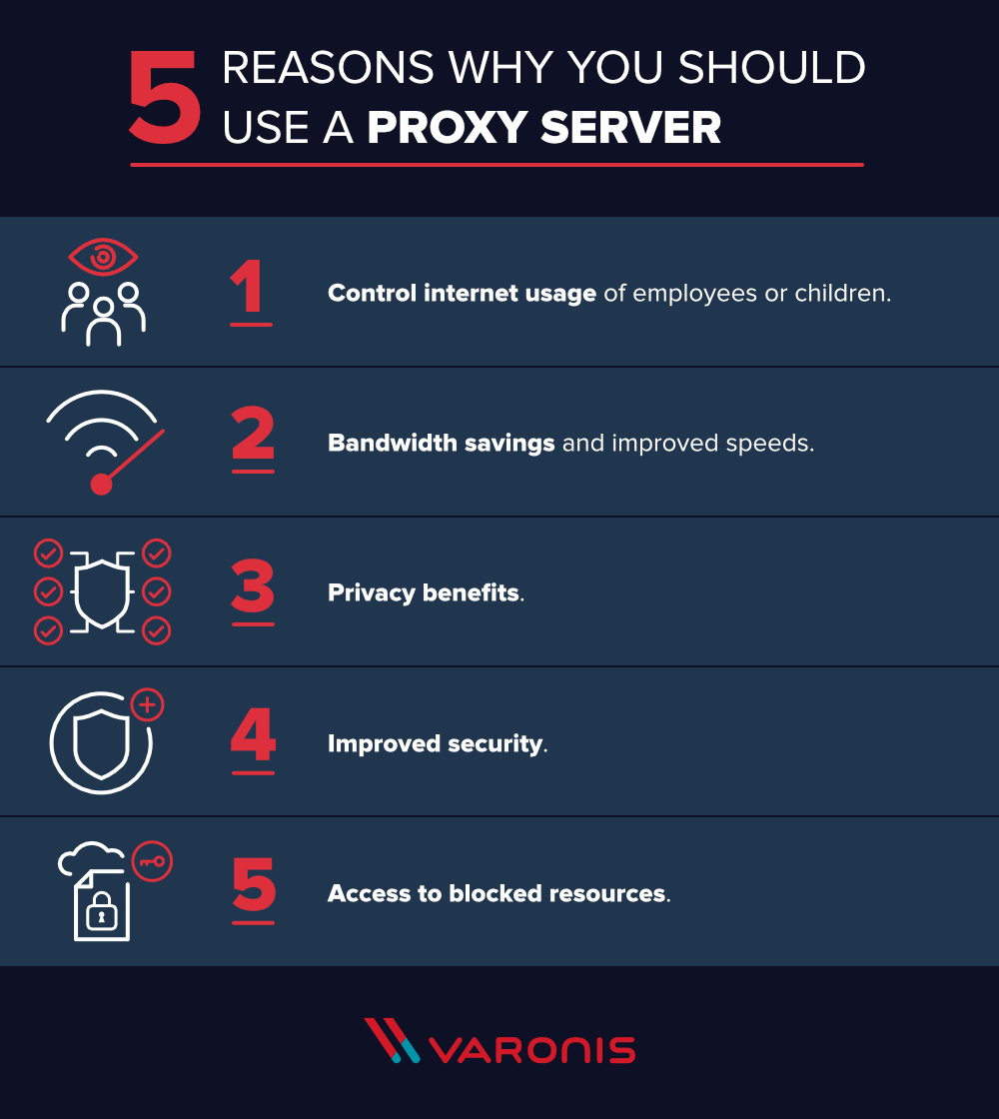

**Proxy Server Risks**

You do need to be cautious when you choose a proxy server: a few common risks can negate any of the potential benefits:

* **Free proxy server risks**
  + You know the old saying “you get what you pay for?” Well, using one of the many [free proxy server services](https://www.wired.com/2015/07/proxy-services-totally-unsecure-alternatives/) can be quite risky, even the services using ad-based revenue models.
  + Free usually means they aren’t investing heavily in backend hardware or encryption. You’ll likely see performance issues and potential data security issues. If you ever find a completely “free” proxy server, tread very carefully. Some of those are just looking to steal your credit card numbers.
* **Browsing history log**
  + The proxy server has your original IP address and web request information possibly unencrypted saved locally. Make sure to check if your proxy server logs and saves that data – and what kind of retention or law enforcement cooperation policies they follow.
  + If you expect to use a proxy server for privacy, but the vendor is just logging and selling your data you might not be receiving the expected value for the service.
* **No encryption**
  + If you use a proxy server without encryption, you might as well not use a proxy server. No encryption means you are sending your requests as plain text. Anyone who is listening will be able to pull usernames and passwords and account information really easily. Make sure whatever proxy server you use provides full encryption capability.

**Types of Proxy Servers**

Not all proxy servers work the same way. It’s important to understand exactly what functionality you’re getting from the proxy server and ensure that the proxy server meets your use case.

**Transparent Proxy**

* A transparent proxy tells websites that it is a proxy server and it will still pass along your IP address, identifying you to the webserver. Businesses, public libraries, and schools often use transparent proxies for content filtering: they’re easy to set up both client and server-side.

**Anonymous Proxy**

* An anonymous proxy will identify itself as a proxy, but it won’t pass your IP address to the website – this helps prevent identity theft and keep your browsing habits private. They can also prevent a website from serving you targeted marketing content based on your location. For example, if CNN.com knows you live in Raleigh, NC, they will show you news stories they feel are relevant to Raleigh, NC. Browsing anonymously will prevent a website from using some ad targeting techniques, but is not a 100% guarantee.

**Distorting proxy**

* A distorting proxy server passes along a *false* IP address for you while identifying itself as a proxy. This serves similar purposes as the anonymous proxy, but by passing a false IP address, you can *appear* to be from a different location to get around content restrictions.

**High Anonymity proxy**

* High Anonymity proxy servers periodically change the IP address they present to the web server, making it very difficult to keep track of what traffic belongs to who. High anonymity proxies, like the [TOR Network](https://en.wikipedia.org/wiki/Tor_(anonymity_network)), is the most private and secure way to read the internet.

**Chapter: 4**

**Introduction to forums, blogging, portfolio, developing a responsive website**

**What’s a Forum?**

According to [Wikipedia](https://en.wikipedia.org/wiki/Internet_forum),

*A forum, or message board, is an online discussion site where people can hold conversations in the form of posted messages.*

According to Google.

*A medium where ideas and views on a particular issue can be exchanged.*

In other words, A forum provides an easy to use interface for members to interact with each other on a topic. The discussions are arranged in forums and sub-forums for categorization. Members share their thoughts, ideas, and interest. Besides, a forum is a valuable resource to connect with other members to get help with queries.

Do not confuse forums with chat rooms. Forums are a little different because they archive the discussions for search and reference.

**What is a Blog?**

According to Wikipedia,

A blog is a discussion or informational website published on the World Wide Web consisting of discrete, often informal diary-style text entries. Posts are typically displayed in reverse chronological order, so that the most recent post appears first, at the top of the web page.

**According to Google.**

*A regularly updated website or web page, typically one run by an individual or small group, that is written in an informal or conversational style.*

A blog is a website that logs views and opinions shared by an individual (or in case of multi-authors – individuals) and displays them in reverse chronological order (newer content appear first).

|  |  |
| --- | --- |
| **Forum** | **Blog** |
| Forum is User Generated Content. | Blog is an Author Generated Content. |
| Members participate in the discussion to share views and ideas. | Author share views and ideas on the blog topic. |
| The discussions are more real-time provided member content doesn’t need to pass the moderation queue. | Apart from comments, interaction with the blogger can have a lag depending on the availability of the blogger. |
| Can take the form of question and answers. | For questions, one has to ask the blogger, and he may answer readers’ questions. |
| Any user can ask a question and other experts in the area can answer the question, | Only the author (or in case of a multi-author blog – authors) responds to readers’ questions. |
| The responses in the forum may not be from an expert in the field and often is the case. | As a blog author, one tends to reply to questions with thorough research. |
| Forum answers aren’t from an authority in the domain. | Blog authors who get a lot of questions from readers are considered an authority in the subject matter. |
| One can’t trust the worthiness of the forum replies. | Bloggers tend to build the trust of the readers and share views and ideas that are trustworthy. |
| Forums are a many-to-many discussion platform. Any member can create a discussion, and others can reply. | Blogs are one-to-many discussion platforms, even if you consider guest article contribution. Readers express views on the article in comments only. |
| Forums are tough to manage. One may need to monitor for spam, content, reply to topics to make it look active, etc. | Blogs, on the other hand, are much easier to manage. |
| Forums are much easier to generate content. | Blogs need a lot of time on research before an author can write about the topic. |
| Forums are tough to get rolling. Members will be interested in creating discussions only when they see an active community. In short, members will create content when they see the others getting their reply or having fruitful discussions. | Blogs, on the other hand, are much easier to start rolling. Even if you don’t have an active reader-base, all one needs is a [motivation to keep blogging](https://biztips.co/motivation-blogging.html). |
| Forums contain user-generated queries, which means there are chances others will have the same questions. Archives will serve the purpose of SEO traffic. | Blog authors need to answer readers’ queries and generate the blog archives to be able to rank well in Google. |
| Google doesn’t make forum discussion as authoritative content. The trustworthiness of the content is also questionable. | Blog authors have an edge when it comes to the authoritativeness and trustworthiness of the content. |
| Forums support social media features like membership, private messages, visitor messages, friends and followers, social groups, member birthdays, etc | Blog lack social media features. |
| You always need to monitor the forum for moderation. | You don’t always need to be blogging. |
| In forums, members are all equal. Anyone can start a discussion on a topic. | For a blog, it is the blogger who starts the topic, and discussion may continue in comments. |

[](https://biztips.co/blog.html)

[What is Blog – Understand the Concept of Blogging](https://biztips.co/blog.html)

A blog is a website that logs views and opinion shared by an individual and displays them in reverse chronological order (newer content appear first).

**Difference between Blogs and Forums**

Both of them are religiously different from each other. So, let’s see the major difference between a forum and a blog on a side by side comparison.

**Which one is easier to grow – a blog or a forum?**

Easier to grow from zero, my vote will be with the blog as compared to a forum. But once there are members, the forum is much easier to grow as compared to a blog.  The question is, at which point you want to know if it is easier to grow a forum or a blog.

So, if you start a forum, one may need discussions to pull members, and one may need members to create discussions — an exact chicken hen problem.

[Reddit](https://www.reddit.com/) is undoubtedly the largest forum online now, and it used to create discussions using multiple accounts.

Today, it is on a self-growth trajectory where members create content and attract new members. Similar is the case with [Quora](https://www.quora.com/) or [StackOverflow](https://stackoverflow.com/" \t "_blank).

Blogs, on the other hand, starting now are much easier to start rolling. Even if you don’t have an active reader-base, all one needs is a [motivation to keep blogging](https://biztips.co/motivation-blogging.html).

My view is, why not have a blog, build a reader-base, and then get them over to a forum.

I did the same for [my Investment blog](https://shabbir.in/), and the [DIY Technical Analysis forum](https://www.diytechnicalanalysis.com/community/) has many discussions flowing now on its own along with members joining even when there is a one time fee to become a member.

**What is the difference between a chat room and a forum?**

Chat rooms are for discussions in real-time, but the chats aren’t archived for future reference.

Moreover, the chat rooms are discussions on a topic without any categorization of the question itself. So if there is a chat room for PHP programming, one can discuss anything on PHP without any definition of sub-topic.

On the other hand, chat rooms are more like Facebook groups where a topic is in chronological order, and no one cares about the content shared in the past.

Whereas in forums, the topics and discussions are arranged under a forum and sub-forum along with an option to search and reference older topics.

**How forums admins and moderators earn money?**

Forum admins are often the forum owners. So they make money using ads or membership. I have an article on [how forum owners can make money](https://biztips.co/make-money-forum.html).

As a moderator, one may be hired by the administrators for moderating the forum. To become a moderator, one may need to contribute to the community before an admin or forum owner wants to hire a member to become a moderator.

Also, forum owners may hire forum admins to overlook the day to day activity in the forum.

**What are the primary uses of a forum as compared to a blog?**

Forums are generally for customer service and support.

As an example, Amazon India has [seller forums](https://sellercentral.amazon.in/forums/) where new members can ask questions. The support staff can respond, but moreover, the other participating members can make the job of the team much more manageable.

Moreover, customers can search the forums for similar questions that are already answered and kept as an archive.